H&M Clothing Retailer Company
Name:
Course:
Institution:
Due date:

H&M Clothing Retailer Company
The H&M organization offers fashion from the manufacturers H&M, COS, & Other Stories, Monki, Weekday and Cheap Monday. All are genuinely described style brands, every with its own specific identity, and that they supplement every different properly. The brands all share the equal ardor for fashion, and the ambition to get dressed customers in a sustainable manner. Together, they offer a wide sort of patterns and developments at numerous rate points. The collections have the entirety from the state-of-the-art developments to undying classics. All the brands try to give customers the fine value for cash. With numerous brands and concepts, the H&M organization offers a huge and varied range of inspiring style. The collections consist of the whole lot of the contemporary tendencies to timeless classics so that customers everywhere in the international can get dressed of their very own private fashion (Żurakowski, n.d.).
H&M’s fashions are created through teamwork, with one of a kind roles working collectively to create collections for clients the world over. Designers, consumers and sample makers are just some of the human beings involved in the innovative manner. Everyone at the crew is equally important. With different nationalities, backgrounds, and experience, they draw proposal from each corner of the arena. New thoughts come from effects as diverse as a tour, films, artwork exhibitions and trend seminars, style suggests, and road fashion. The diversity of the collections permits clients to combine pieces in particular reflections in their personal style, flavor, and needs for wear over some of the seasons. Sustainability is important to nowadays customers, and this is mediated in H&M’s material alternatives among different things. More sustainable materials together with natural cotton, recycled polyester, and recycled wool make up an increasing part of H&M’s product variety.
H&M is working to make sustainable fashion available to as many human beings as feasible. As a global fashion organization, H&M is dependent on a long-time period supply of herbal sources and stable sourcing markets. Working for expanded sustainability is critical to the business enterprise’s lengthy-time period achievement. This work is, therefore, a quintessential a part of the enterprise and includes components along with environmental issues, ethics, and human rights. H&M’s sustainability paintings cover the complete garment existence cycle and additionally includes how the stores are run, the way to get employees engaged and a way to assist customers in making sustainable alternatives.
As a corporation with strong values and an extended-term technique, H&M makes use of its length and impact to bring about higher conditions for people and to decrease environmental impact at some point of the price chain. Progress is made possible via collaborations, innovation, and more transparency. Along with clients, providers, commercial enterprise partners, scientists, interest corporations, selection makers and different organizations,
H&M is working all along the line from developing the conditions for sustainable cotton manufacturing and selling fair dwelling wages for textile employees, via the use of renewable power, to encouraging customers to be climate smart whilst washing garments and to recycle old apparel. For H&M, the aim is in an effort to continue to grow.
Full-year from 1 December 2014 to 30 Nov 2015 Well-obtained collections for all manufacturers inside the H&M group ended in true sales of SEK 210 billion together with VAT and improved market share. The H&M institution’s sales apart from VAT extended through 19 percent to SEK a hundred and eighty, 861 m (151,419) during the economic year. In neighborhood currencies, the growth changed into eleven percent. Gross earnings accelerated via 16 percentage to SEK 103,167 Million. This corresponds to a gross margin of 57.0 percentage.
Profit after economic items multiplied through SEK 1.3 billion and amounted to SEK 27,242 Million, a growth of 5 percentage. The institution’s profit after tax multiplied to SEK 20,898 Million, corresponding to SEK 12.63 consistent with percentage, a growth of 5 percentage. The profit growth for 2015 has brought about SEK 75 Million being allocated to the H&M Incentive Program (HIP) that is for all employees. Very strong enlargement all through the year with a total internet addition of 413 new shops and ten new on-line markets. At the end of the economic year, H&M had 23 online markets and the variety of shops amounted to a few, 924 in sixty-one markets (Żurakowski, n.d.).
According to (Wolk, 2009), More than 16,000 new jobs were created within the H&M institution in 2015. The wide variety of personnel amounted to extra than 148,000 at the stop of the 12 months. For the Fourth zone from 1 September 2015 to 30 Nov 2015 The H&M organization’s sales in SEK except for VAT expanded by using 14 percent to SEK 48,694 Million during the fourth quarter. In neighborhood currencies, the growth became 9 percentage.
Gross income amounted to SEK 27,997 Million, a boom of 9 percent. This corresponds to a gross margin of fifty-seven. Five percent).Profit after economic items amounted to SEK 7,148 Million. The organization’s profit after tax amounted to SEK five, 526 Million, similar to SEK 3.34 in line with proportion. Profits in the zone have been negatively affected by appreciably higher shopping expenses because of the strengthened US greenback.
The correct start for H&M’s first shops in India, New Delhi and in South Africa, Cape Town. The Board of Directors proposes a dividend of SEK 9.75 in line with a share for the 2014/2015 economic year. Sales which includes VAT in December 2015 accelerated with the aid of 10 percentage in local currencies as compared to the corresponding month the previous 12 months. Sales including VAT in January 2016 are anticipated to growth by means of 7 percentage in local currencies in comparison to the same month ultimate 12 months. The H&M group plans an internet addition of round 425 new shops for the 2015/2016 monetary year. Most of the growth will take area in present markets. New Zealand, Cyprus, and Puerto Rico are planned to become new H&M markets. In addition, H&M plans to offer e-commerce in a, in addition, nine current H&M markets.
Gross profit and gross margin
H&M’s gross income and gross margin are an end result of many different factors, internal as well as external, and are mainly suffering from the decisions that H&M takes in keeping with its method to usually have the excellent consumer imparting in each character marketplace – based totally on the combination of style, excellent, rate and sustainability. Gross income extended to SEK 24,466 Million within the first zone, corresponding to a gross margin of 52.1 percent Markdowns on the subject of income extended via zero.3 percent factors within the first area 2017 in comparison to the corresponding zone in 2016.
Overall, the market situation as regards external elements such as buying currencies and uncooked materials endured to be slightly terrible at some point of the buying duration for the first sector in comparison to the corresponding buying period inside the preceding year. For purchases made for the second first sector of 2017, the general market situation for the outside factors is also considered barely bad average in comparison to the corresponding purchasing duration the preceding 12 months.
Cost manage in the organization remains proper. For the primary sector of 2017, promoting and administrative fees improved by 10 percentage in SEK and by using 7 percent in local currencies as compared to the primary quarter remaining year. Profit after economic items inside the first zone 2017 amounted to SEK 3,212 Million, a decrease of 3 percent. Development of income in the first sector is more often than not explained through the reality that income did no longer increase as a whole lot as planned and by way of better mark-downs.
Stock-in-exchange amounted to SEK 32,692 Million, a growth of 30 percentage in SEK and 28 percentage in nearby currencies as compared to the end of February remaining year. The growth within the inventory-in-alternate is explained with the aid of the organization’s endured robust expansion, but additionally by means of the truth that the income growth in the area turned into beneath plan. As an end result, stock-in-change as of 28 February 2017 turned into better than planned however different than this, the composition of the inventory-in-exchange is deemed to be desirable.
The stock-in-alternate amounted to 67 percent of income excluding VAT, rolling twelve months and 33.4 percentage of general assets expansion. The growth goal of the H&M group is to increase sales in neighborhood currencies through 10 – 15 percentage in keeping with year with persevered high profitability. In 2017 new markets for H&M shops may be Kazakhstan, Colombia, Iceland, Vietnam and Georgia. The first H&M shop in Kazakhstan opened in Almaty on 18 March and become very properly obtained. Six new H&M online markets are deliberate to open within the first half of 2017: Turkey, Taiwan, Hong Kong, Macau, Singapore, and Malaysia. For full-year 2017 an internet addition of about 430 new shops is planned. Most of the brand new stores in 2017 might be H&M stores and approximately 70 to 80 shops will consist of COS, & Other Stores.
H&M Home departments planned for 2017. The first impartial H&M Home shops are planned to open in mid-2018.In correspondence with the enlargement, the shop portfolio is being optimized as regards the number of stores, save area, rebuilds, and relocations if you want to usually make sure that the shop portfolio is proper for every marketplace. In the first area, the organization opened sixty-eight stores and closed 26 stores, a net increase of forty-two new stores. The organization had 4,393 stores as of 28 February 2017, of which 193 are operated by way of franchise companions (2017).
Tax
The H&M organization’s tax price for the 2016/2017 economic 12 months is anticipated to be 22.5 – 23. However, all through the primary three-quarters of the 12 months, an anticipated tax rate of 23.5 percentage could be used. The very last final results of the tax fee for the year depends on the consequences of the institution’s numerous corporations and the corporate tax quotes in each United States.
Financing
In the primary quarter, the H&M group signed a revolving credit score facility (RCF) of EUR seven hundred m as a way to boom financial flexibility.

Current region
Sales inclusive of VAT in the length 1 March to 28 March 2017 improved with the aid of 7 percentage in nearby currencies in comparison to the same duration the preceding year.Sales in March, April and May ought to be regarded together, partly due to the fact the Easter excursion falls in specific months in one-of-a-kind years and partially because the climate throughout this period can range significantly from year to year.
Accounting principles
The organization applies International Financial Reporting Standards (IFRS) as adopted by the EU. This document has been organized in step with IAS 34 Interim Financial Reporting as well as the Swedish Annual Accounts Act. The accounting standards and calculation methods carried out on this record are unchanged from the ones used in the training of the annual file and consolidated monetary statements for 2015 which might be described in accounting standards.
H & M Hennes & Mauritz AB’s financial instruments consist of bills receivable, different receivables, cash equivalents, bills payable, amassed change payables, interest-bearing securities, and foreign money derivatives. Currency derivatives are measured at an honest fee based on input information similar to degree 2 of IFRS thirteen. As of 28 February 2017, ahead contracts with a positive market cost quantity to SEK 439 Million, which is reported under other contemporary receivables. Forward contracts with a bad marketplace cost quantity to SEK 562 Million, that's reported underneath different contemporary liabilities (Solomon, & Solomon, 1993).
Other financial assets and liabilities have quick terms. It is consequently judged that the honest values of those financial devices are approximately equal to their e-book values. The parent agency applies the Swedish Annual Accounts Act and the Swedish Financial Reporting Board’s advice accounting for Legal Entities, which essentially entails making use of IFRS. In accordance with (Żurakowski, n.d.) the figure organization does no longer follow IAS to the size of financial contraptions; nor does it capitalize improvement expenditure.
Risks and uncertainties
A Number of issues may additionally affect the H&M group’s effects and business. Many of those can be treated via internal workouts, while certain others are affected more by means of external influences. There are risks and uncertainties associated with fashion, climate situations, macroeconomic and geopolitical adjustments, sustainability problems, overseas forex, tax and one of a kind policies however additionally in connection with enlargement into new markets, the launch of new principles and how the brand is controlled. There also are some risks related to the group’s recognition, so-referred to as “reputational dangers” (Everson, & Vos, n.d.).

H&M Clothing Retailer Company income statement summary.

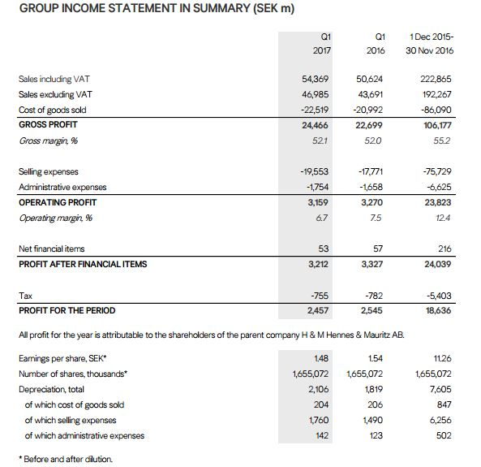

H&M Clothing Retailer Company consolidated statement of comprehensive income.
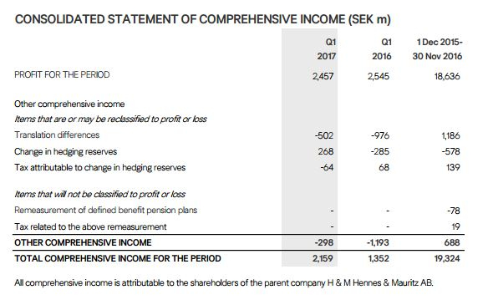
H&M Clothing Retailer Company balance sheet summary.
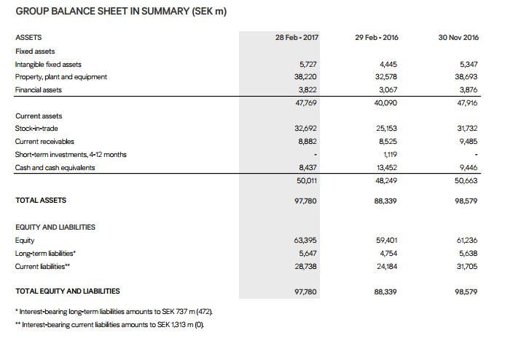
H&M Clothing Retailer Company five year financial summary.
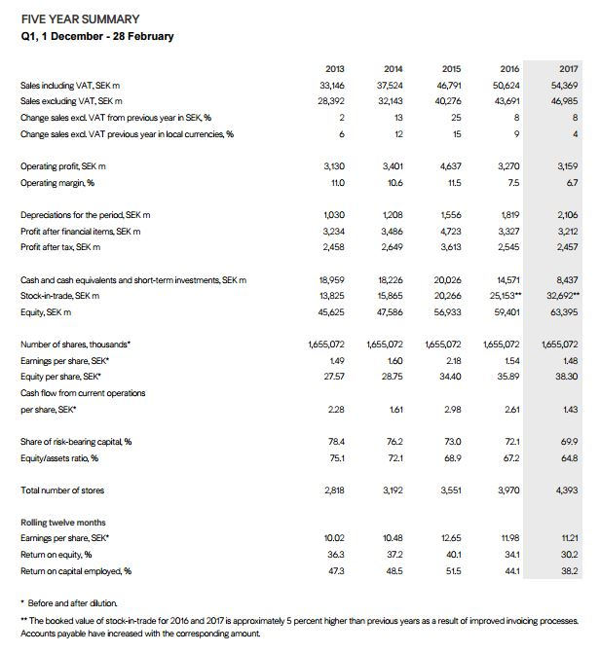

References

(2017). Retrieved 30 April 2017, from http://H&M clothing retailer company

Everson, M., & Vos, E. Uncertain risks regulated (1st ed.).

Solomon, L., & Solomon, L. (1993). Accounting principles (1st ed.). Minneapolis, Minn.: West Pub. Co.

Wolk, H. (2009). Accounting Theory (1st ed.). Los Angeles: Sage.

Żurakowski, M. Risk Management in Value Creation: The Example of Clothing Industry Company. SSRN Electronic Journal. http://dx.doi.org/10.2139/ssrn.2260902

